CS:GO Case Opening Simulator

User Manual

Oscar Reinitz

Table of Contents

Preface 2

Operation Of the Website 2

Picking a balance 2

Case Selection Screen 3

Viewing Case Contents 3

Opening a Case 3

Searching for a Case 3

Reloading website data 4

Using the Inventory 4

Selling Items 4

Ending the Simulation 5

Resetting simulation data 5

# Preface

This user manual is for operation of the CS:GO Case Opening Simulator. It features every single operation you may undertake as a user of this software, with conceptual and procedural explanations for each topic. A table of contents exists for the quick location of desired topics and images are provided for each process described in this manual.

# Operation Of the Website

## Picking a balance

When the website is first initiated or is reset, an array of balances will be available for choice by the user. This balance will be used as your starting amount of money for the simulation session.

Three buttons are available to click on, each with a different starting balance, indicated by the text caption in each box. An image also exists to visually communicate each amount’s size in comparison to each other.

## Case Selection Screen

### Viewing Case Contents

The site presents each case in a grid, allowing users to view the contents of a case they desire. The site constantly displays the current wallet balance in the top right corner of the screen.

The case icon will jiggle, and its grid box light up when the mouse is hovered over it. To view the contents of a case, hover the mouse over its defined grid square and left click.

### Opening a Case

Once a case is in view a user has the ability to roll the case, deducting its price from the user balance and producing an item based on the defined odds from the game.

To open a case click on the large button which states “Open Case”. An animation will play, and the won item will be displayed. When the animation is playing the buttons to exit and open the case will temporarily disappear to allow the animation to play.

### Searching for a Case

Users have the ability to search for a desired case when viewing the large grid of cases. A binary search algorithm is used to process user input and display the desired case.



To search for a case, enter the case name in the search bar and left click the magnifying glass icon to display the requested item. Invalid search terms will return an error message.

### Reloading website data

Users have the ability to reload the data file which is used to populate the case grid and date for the items. This is used when users encounter server-based errors that may have resulted due to their network connections. It is only needed in very rare cases.

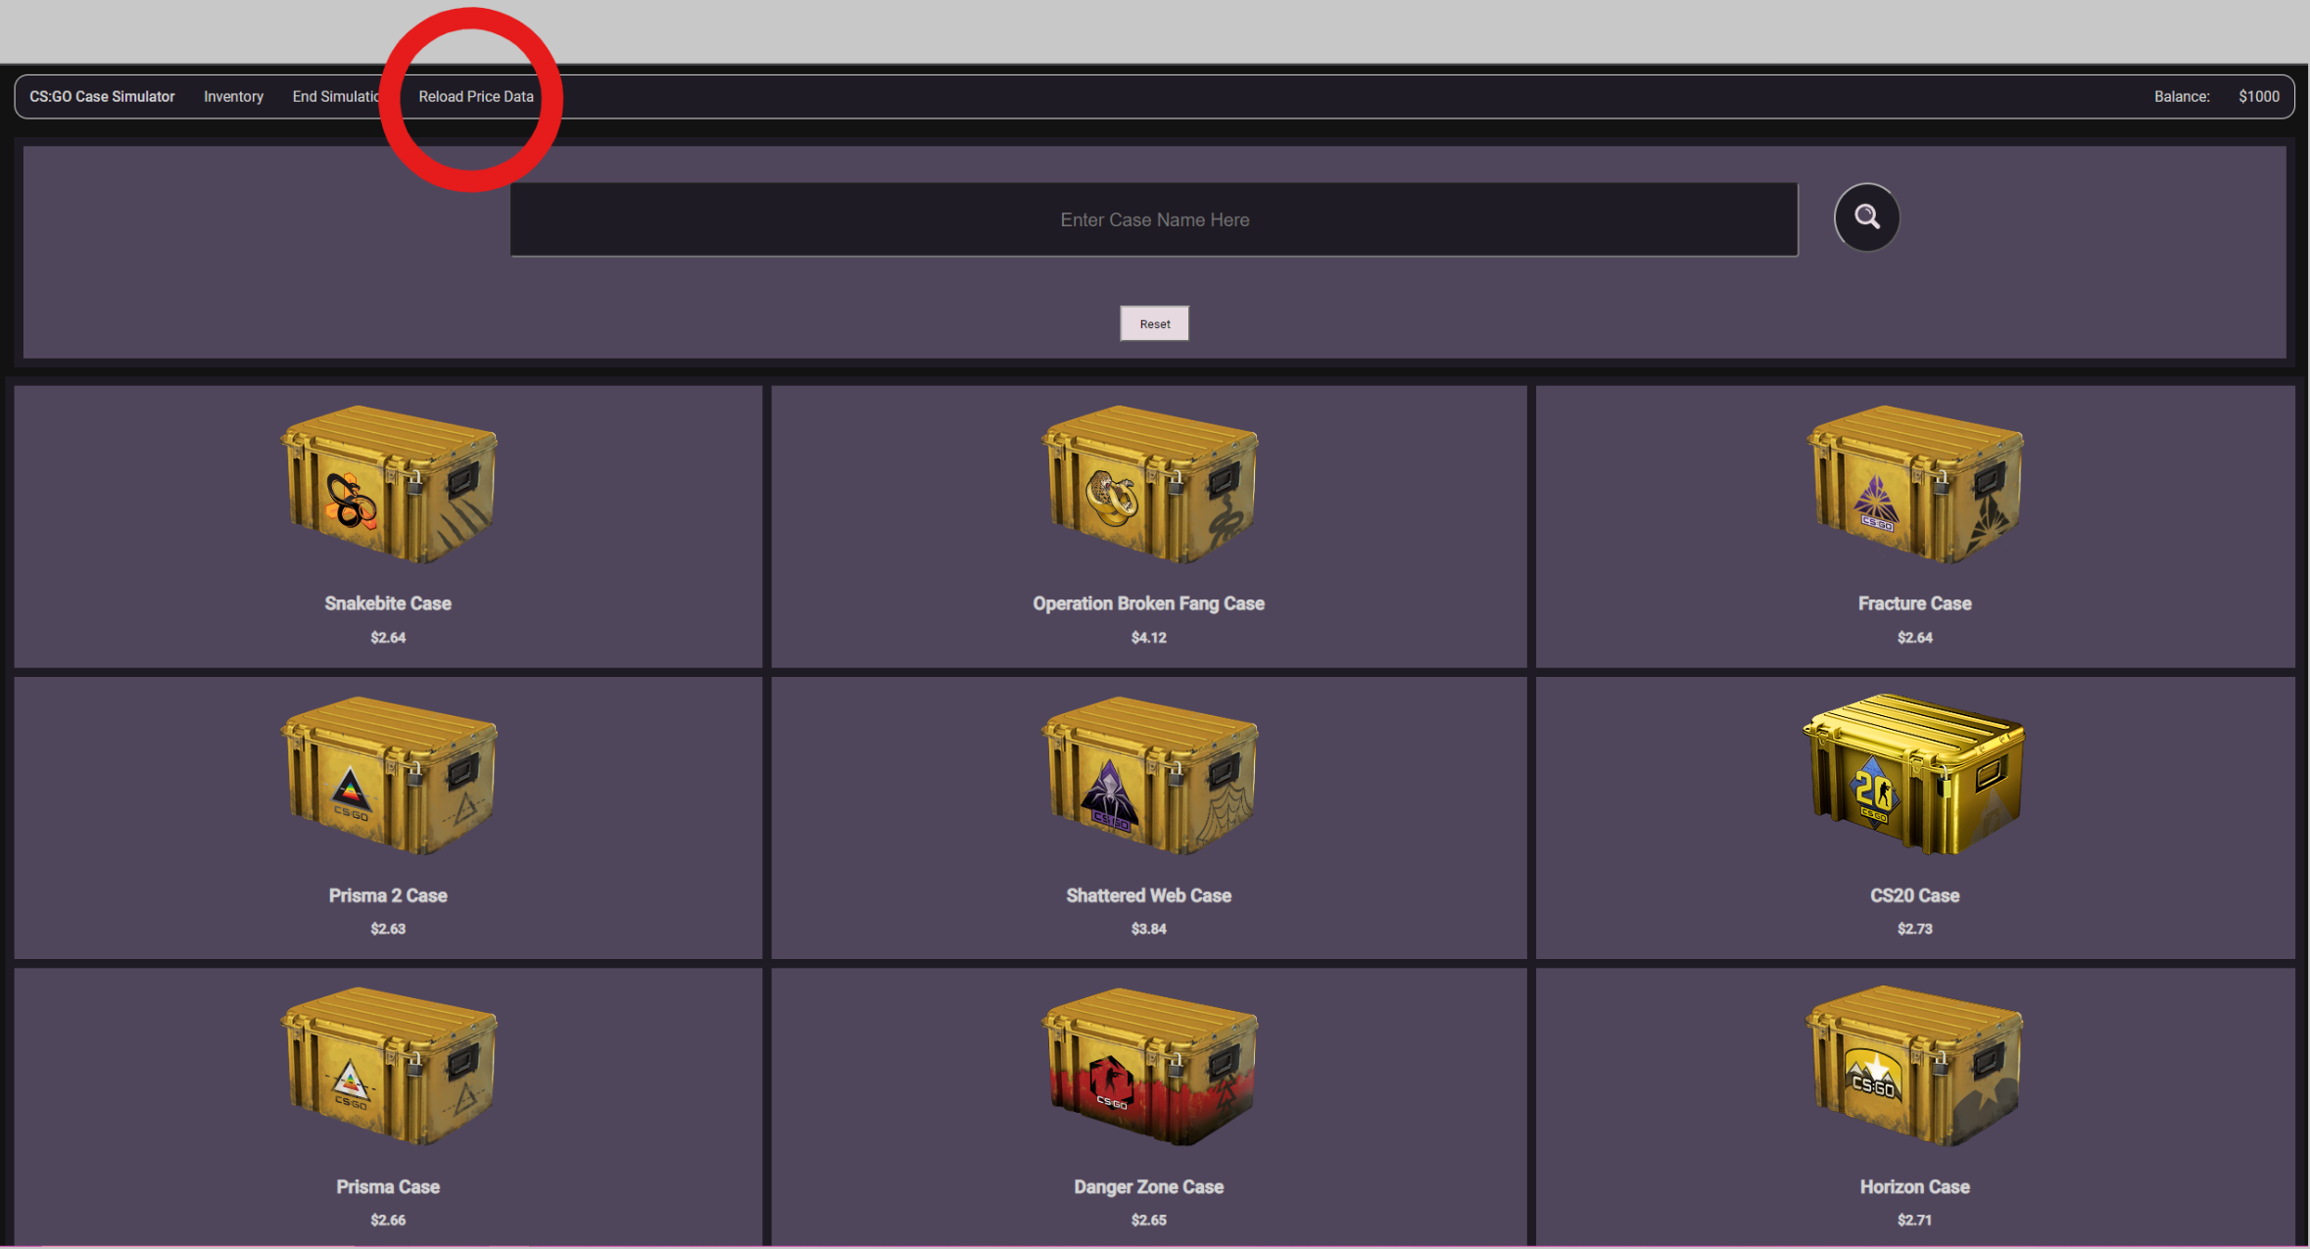

To reload the site, left click the reload button on the top toolbar, as indicated in the image by the large red circle. A loading image will briefly display as the database is reloaded, then the case grid will return into view.

## Using the Inventory

### Selling Items

Users have the ability to sell items in their inventory, the value of the item being added back into their balance indicated in the top right corner of the screen.

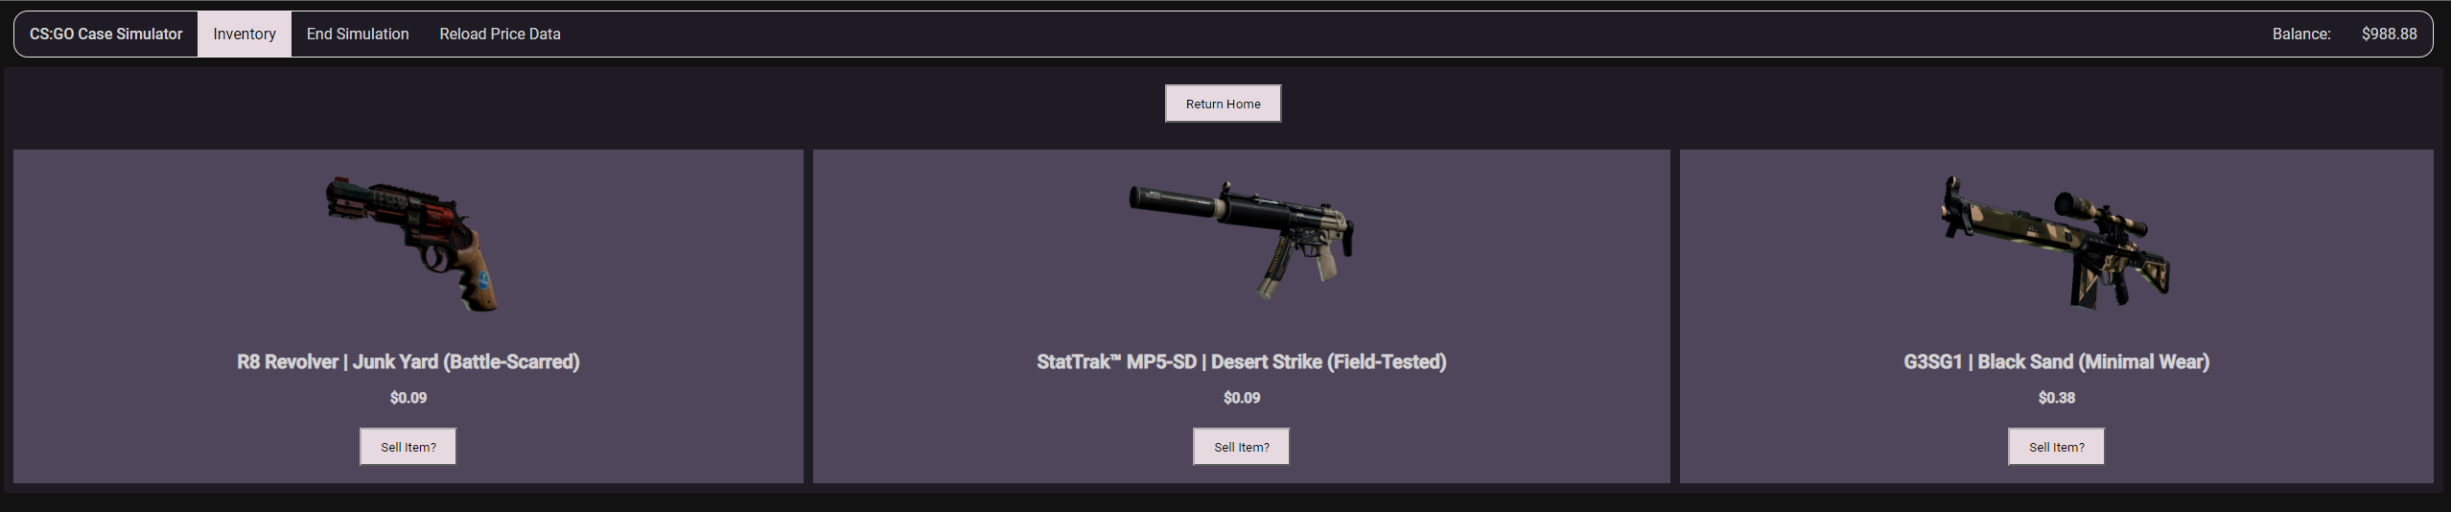

To sell an item navigate to the inventory using the tab labelled “Inventory” on the top toolbar. Each item in your inventory displays a price, which it is worth, and a button which will sell the item. To sell an item, left click the “Sell Item” button in the grid cell of the desired item you will sell. The value of the item will then be added to your wallet balance.

## Ending the Simulation

### Resetting simulation data

When a user has either run out of money or decides to end their session, they have the ability to view statistics on their session and reset the entire simulation. This clears local storage variables of their session and returns them to the home page to begin a new session.

To reset your simulation navigate to the “Results” page via the tab labelled “End Simulation” on the top toolbar. A series of statistics for your session will be displayed. To reset the simulation, left click the button labelled “Reset Simulation” at the base of the page, this will return you to the home page and allow you to pick a starting balance if you wish to play again.